**Fitur FAMOS Bussines and Talent Matching**

1. **Client Module**
   1. Authentication ( Register – Email Verification – Login )
   2. Client Home
   3. Dashboard Proyek
   4. Setup Cintact
      1. Key Details
      2. Brief
      3. Contact Details
   5. Timeline Management
   6. List Brief
      1. Brief Waiting
      2. Brief Reject
      3. Brief Unfinished
      4. Brief Running (Proyek)
   7. Peyment Brief (integrated peyment gateway)
   8. Inbox
   9. Profil Edit
   10. Notification
   11. Notification Setting
   12. Masukan Kritik dan Saran
2. **Admin Module**
   1. Dashboard (report Income , total Brief , total Proyek ,total Clients)
   2. Master Admin
   3. Master Kategori Tipe Proyek
   4. Master Bidang Perusahaan
   5. Setting Sensor Sistem (Inbox)
   6. Data Client Register
   7. List Brief Client
   8. List Proyek Masuk
   9. Detail Proyek (dan Submit design proyek dan trigger ke timeline)
   10. Detail Brief
   11. Upload Feedback / Report per Proyek trigger timeline
   12. Lihat Kritik dan Saran
   13. Website Setting (Landing Page)
       1. Home
       2. Contact Us
       3. About Us
       4. Location Maps
       5. Upload Identiy (logo , link ig , link fb , etc.)
       6. Input SEO
   14. Analytics Report Income detail (with export excel / pdf)
3. **Talenta Module**
   1. Dashboard (report Income , total Brief , total Proyek ,total Clients)
   2. Authentication ( Register – Email Verification – Login )
   3. List Brief Client
   4. List Proyek Masuk
   5. Detail Proyek (dan Submit design proyek dan trigger ke timeline)
   6. Detail Brief
   7. Upload Feedback / Report per Proyek trigger timeline
   8. Analytics Performance
   9. Profile Setting
   10. Peyment Withdraw
   11. Masukan Kritik dan Saran

**Use Case Diagram**

* **Client**

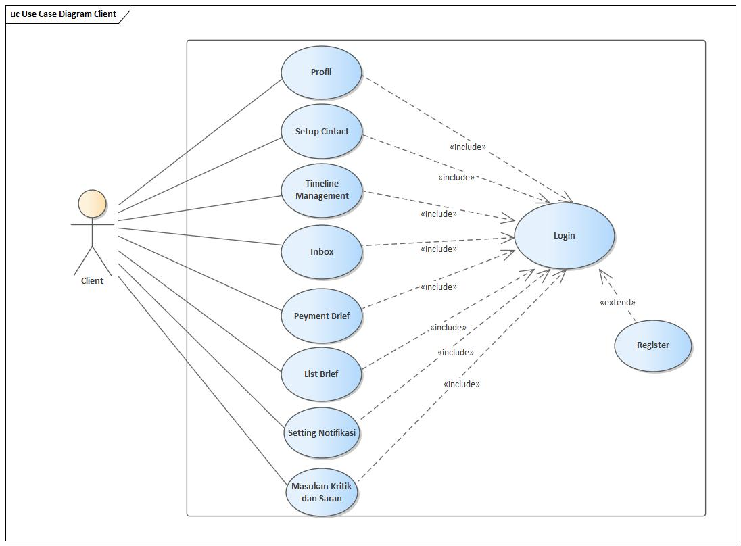

* **Admin**

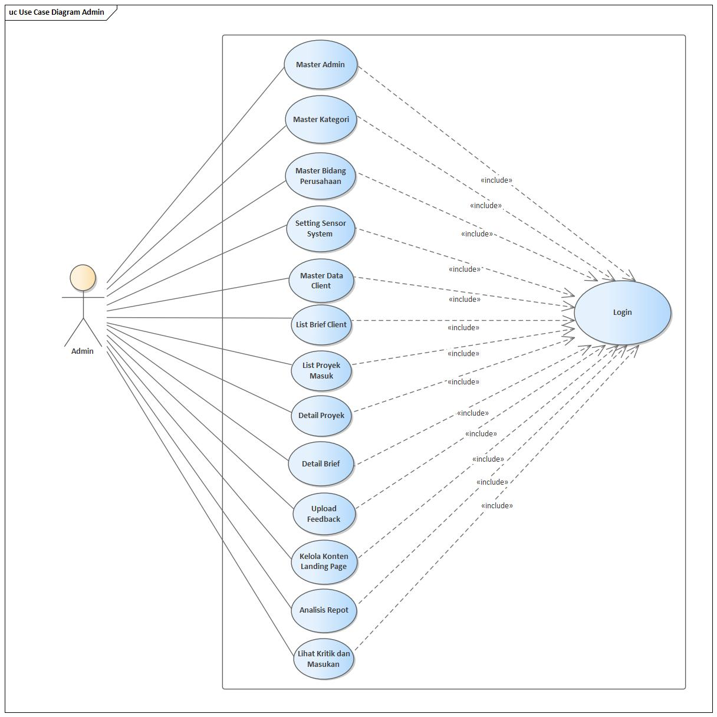

* **Talenta**

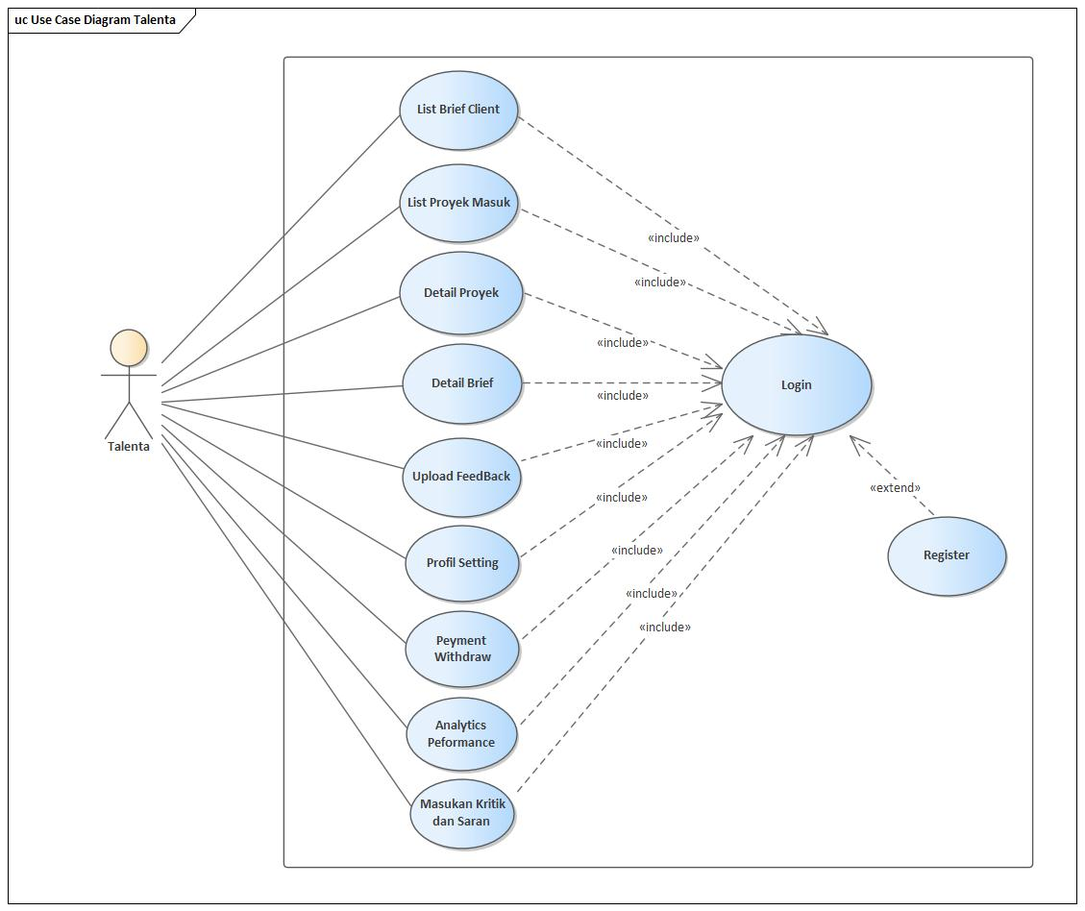

**Activity Diagram Client**

* 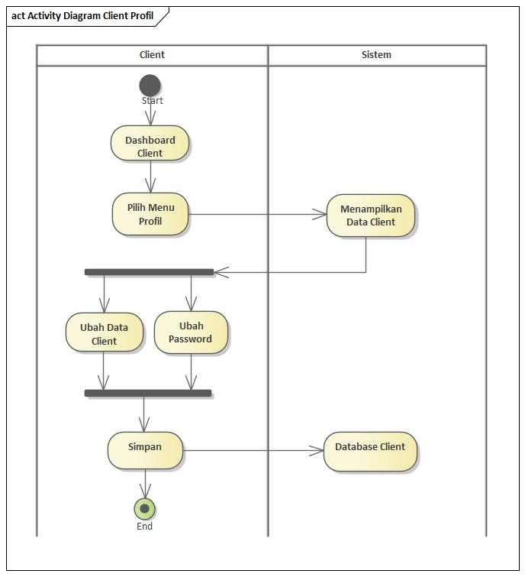**Profil**
* 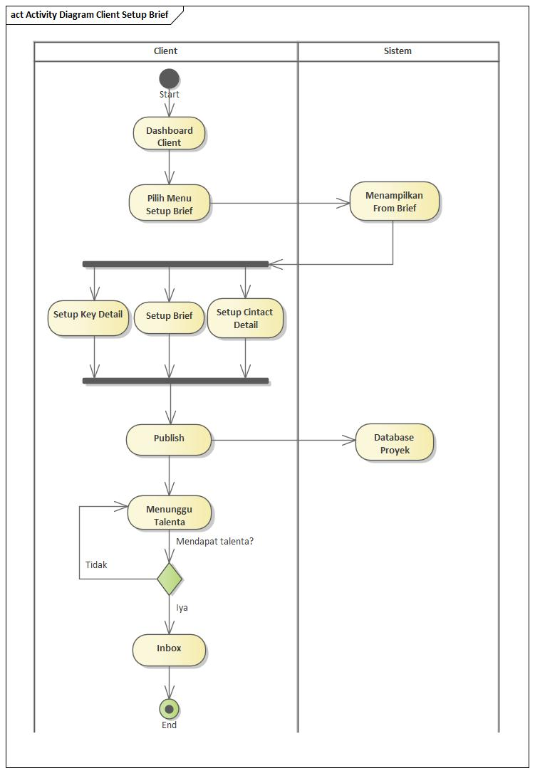**Setup Cintact**
* **Timeline Management**

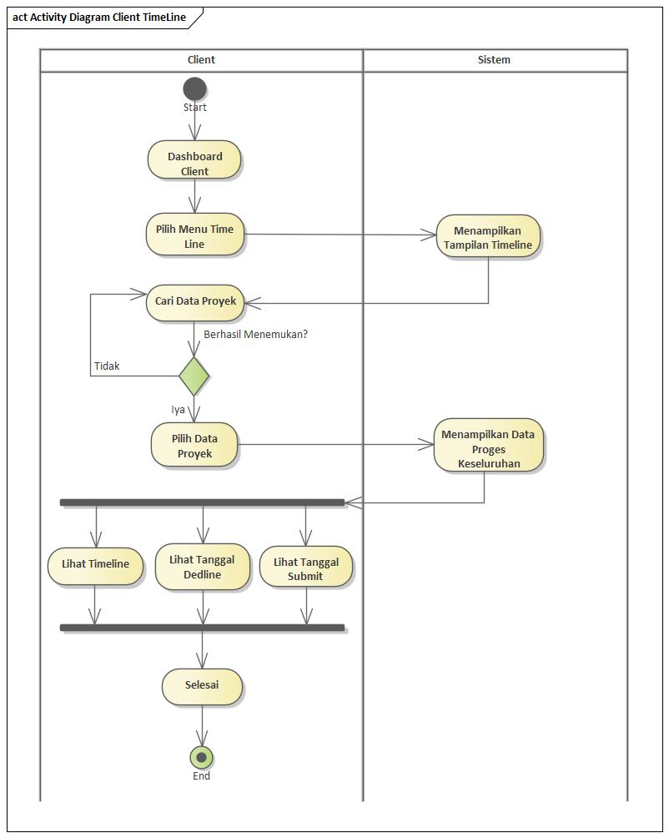

* **Inbox**

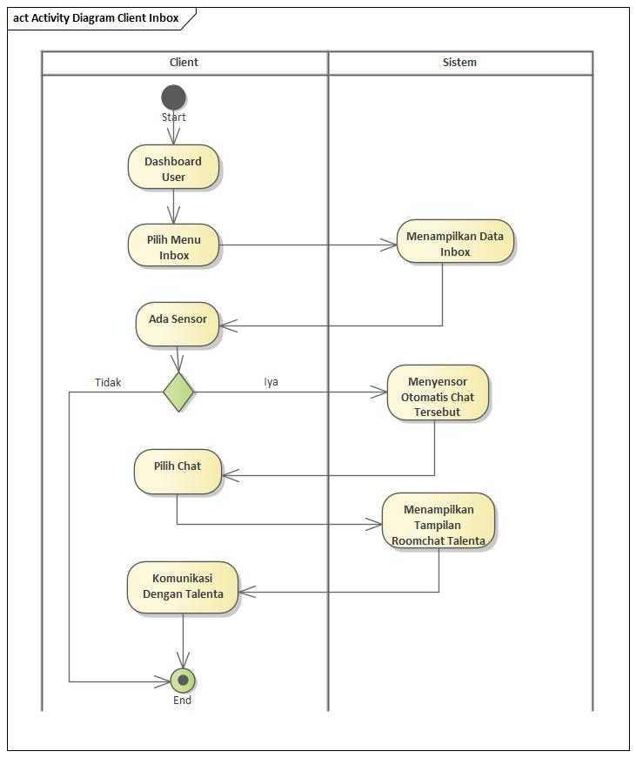

* 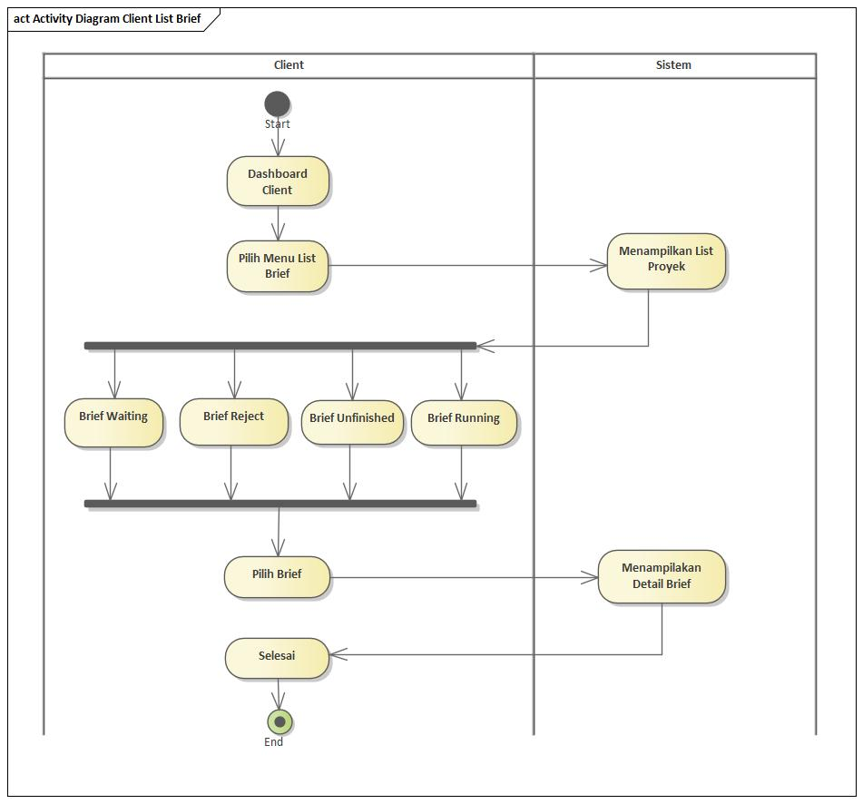**List Brief**
* 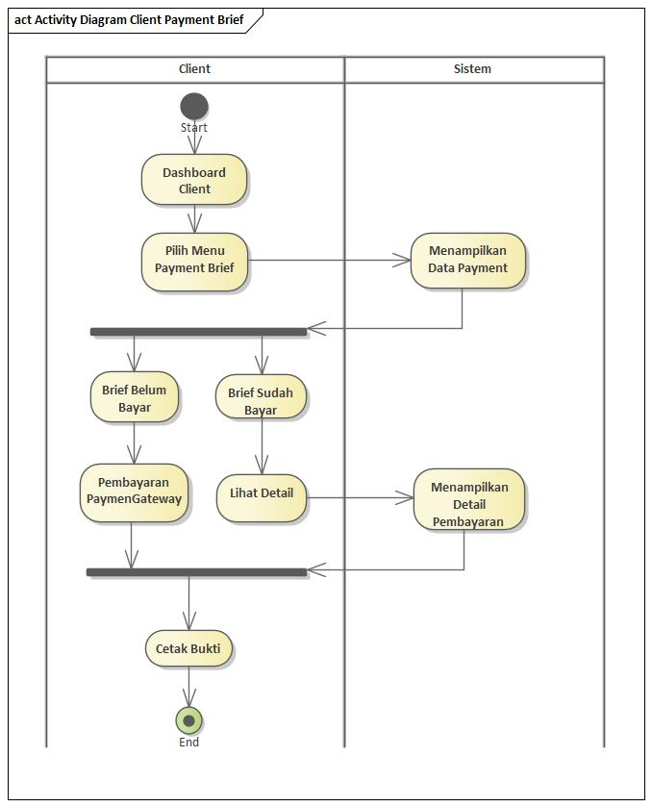**Payment Brief**
* 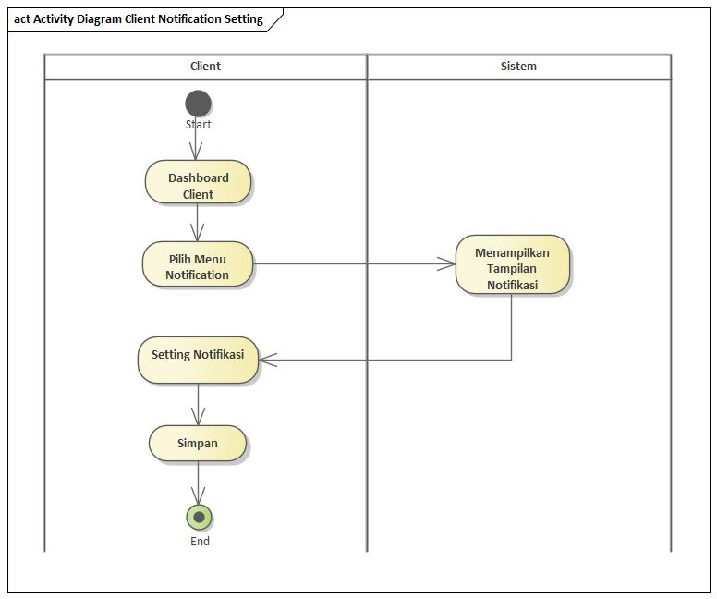**Setting Notifikasi**
* 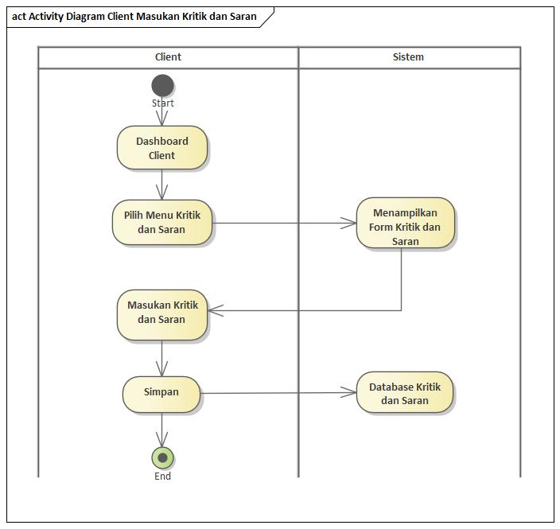**Masukan Kritik dan Saran**
* **Login & Register Client**

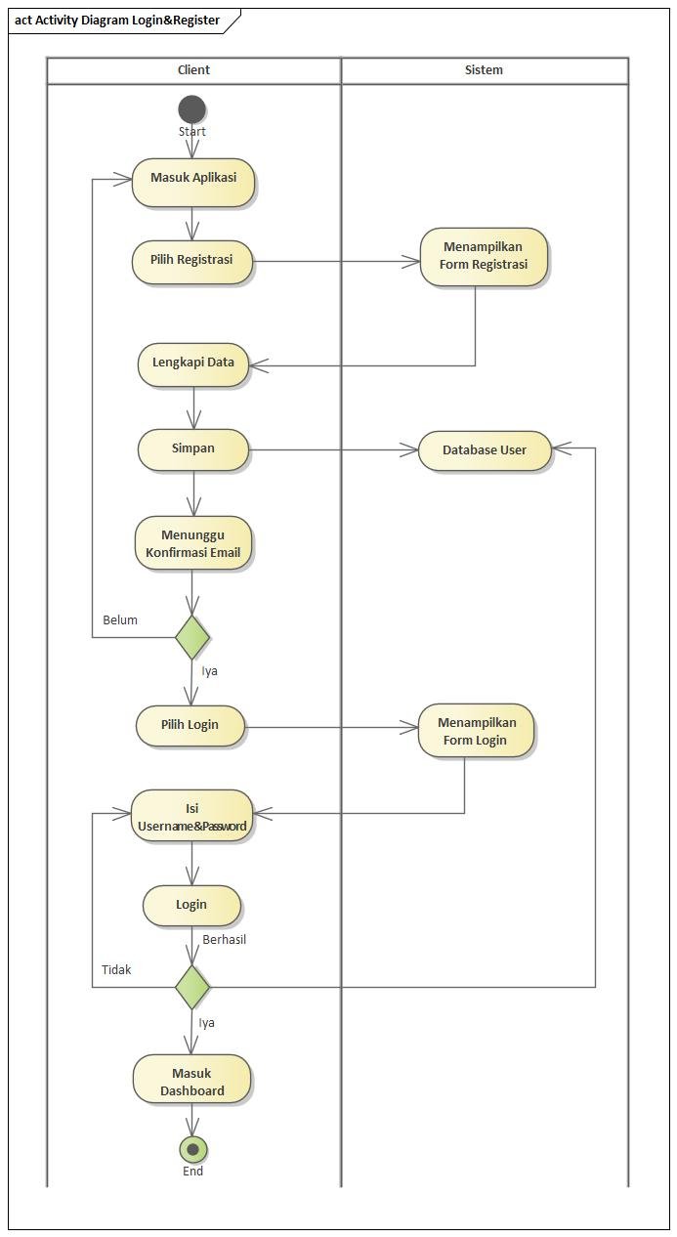

**Activity Diagram Admin**

* 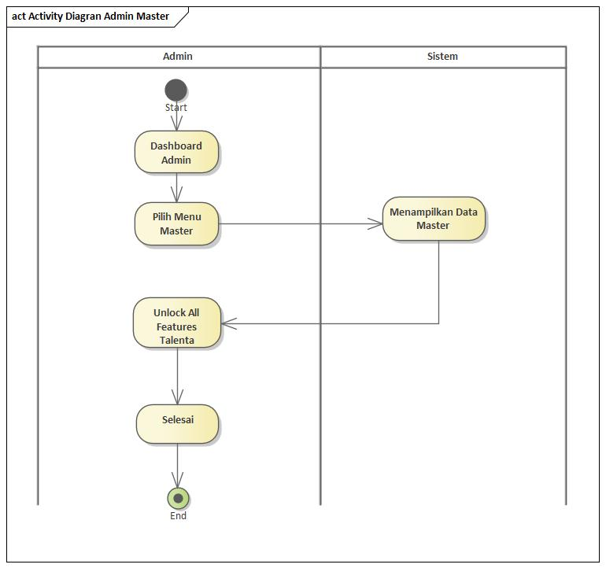**Master Admin**
* 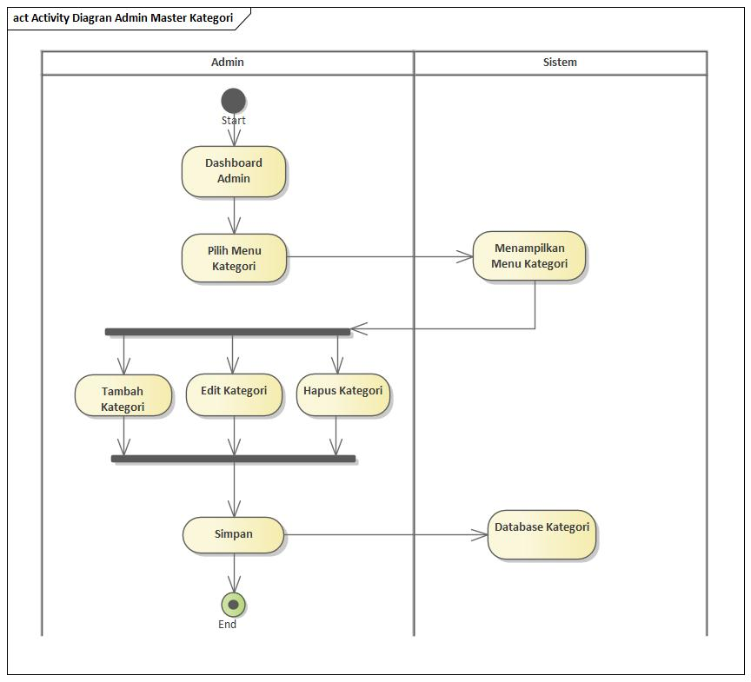**Master Kategori**
* 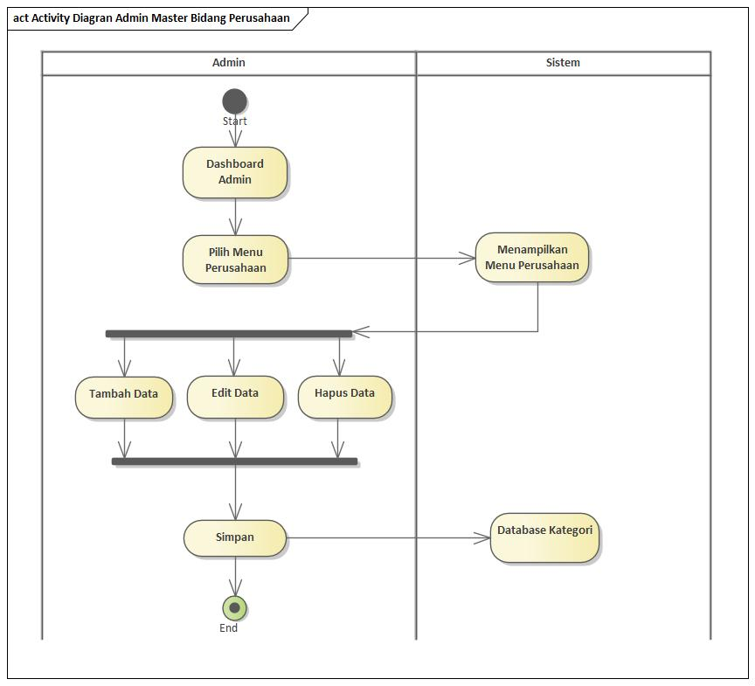**Master Bidang Perusahaan**
* **Setting Sensor System**

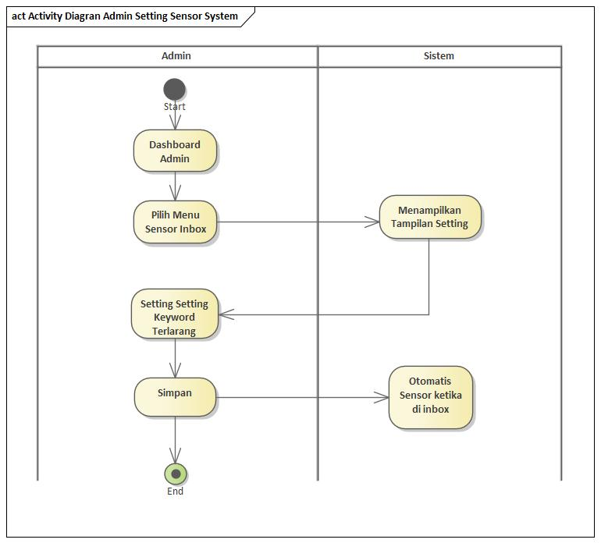

* 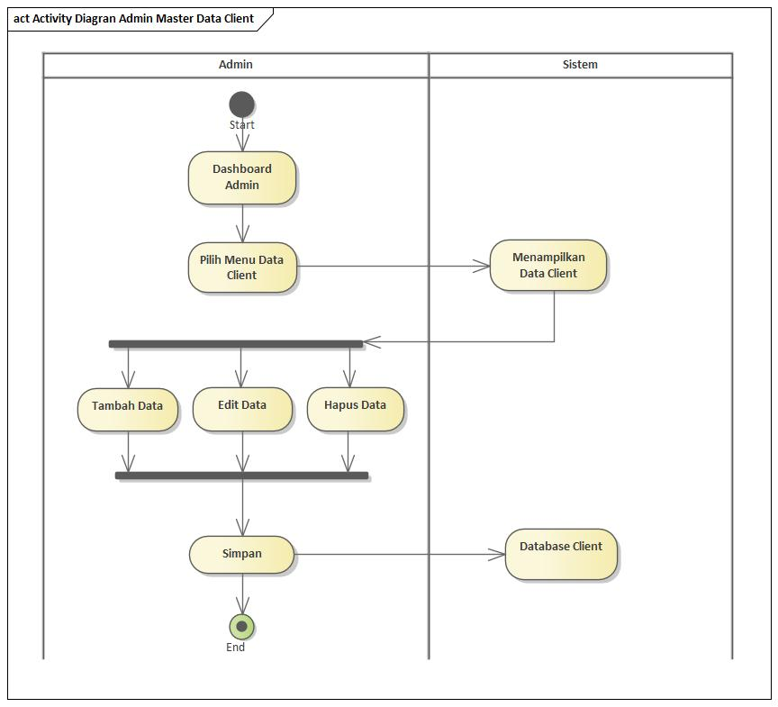**Master Data Client**
* 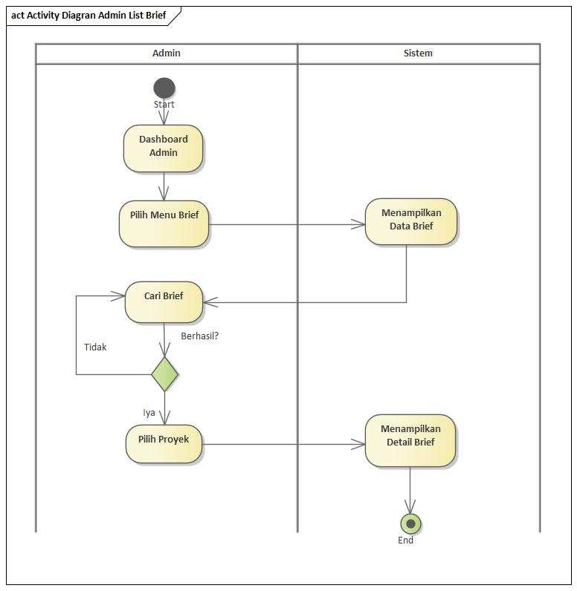**List Brief Client**
* 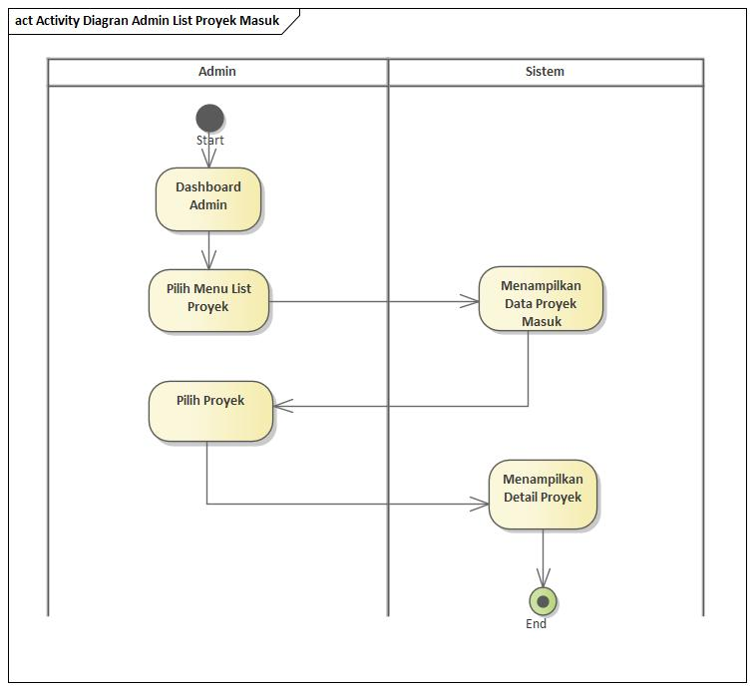**List Proyek Masuk**
* 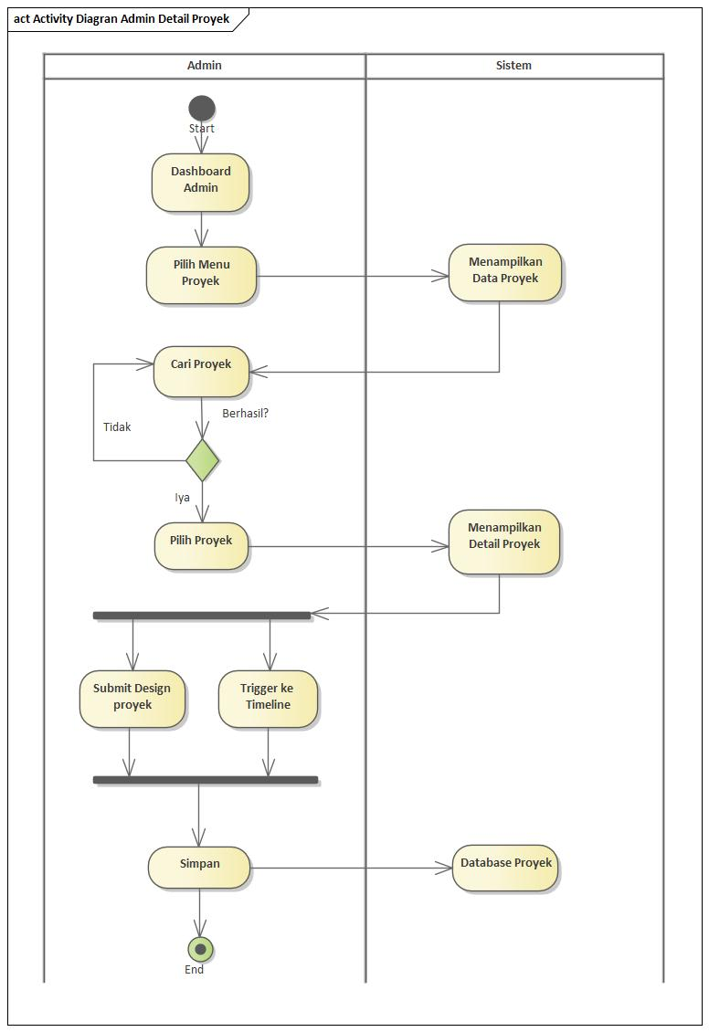**Detail Proyek**
* 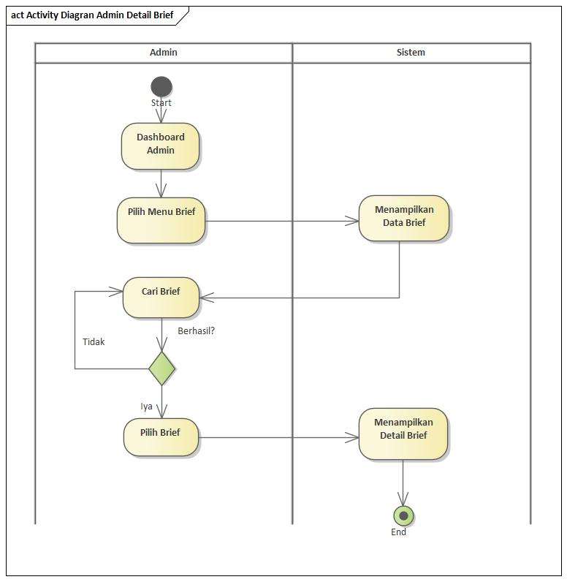**Detail Brief**
* 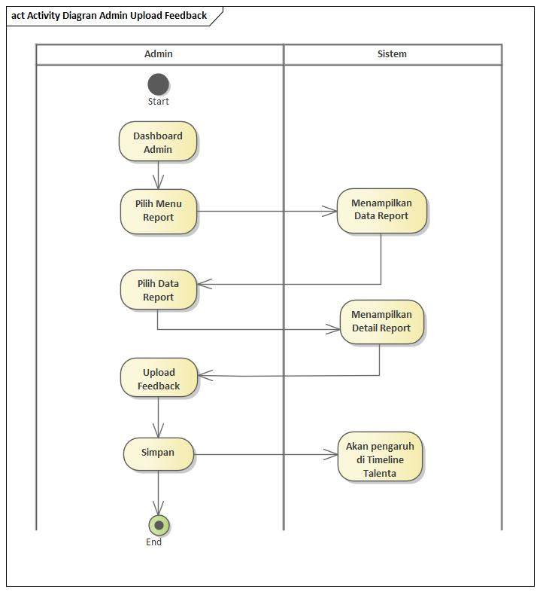**Upload Feedback**
* 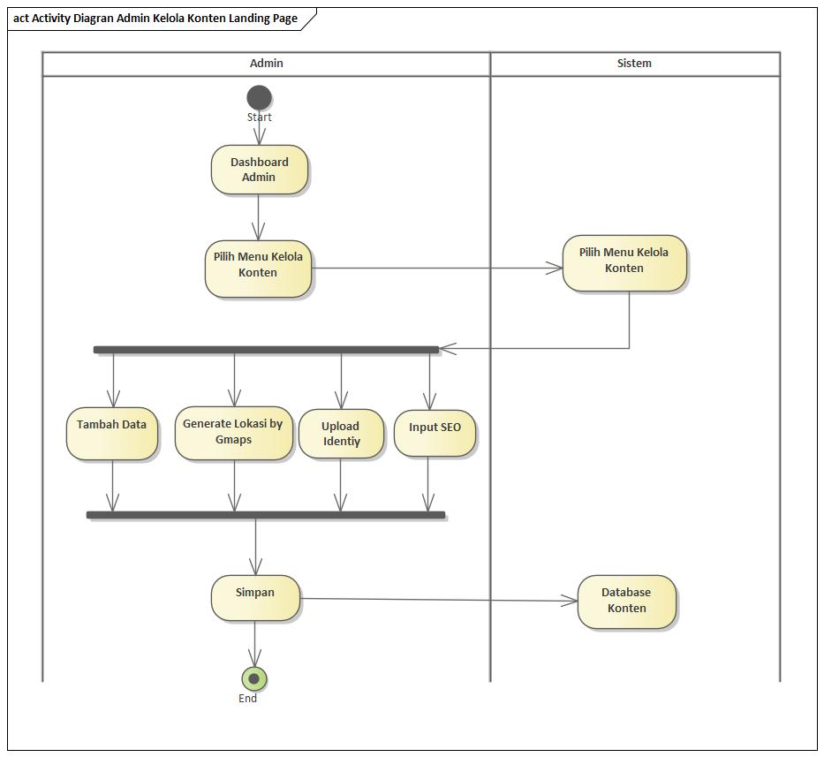**Kelola Konten Landing Page**
* 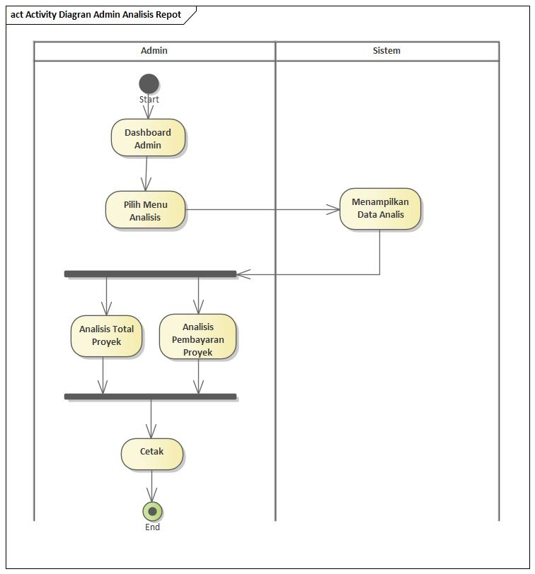**Analisis Report**
* 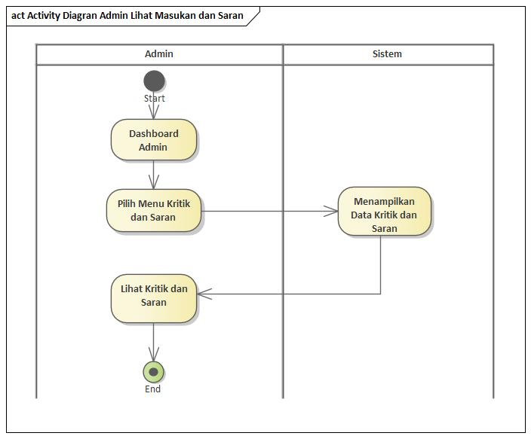**Lihat Kritik dan Saran**

**Activity Diagram Talenta**

* 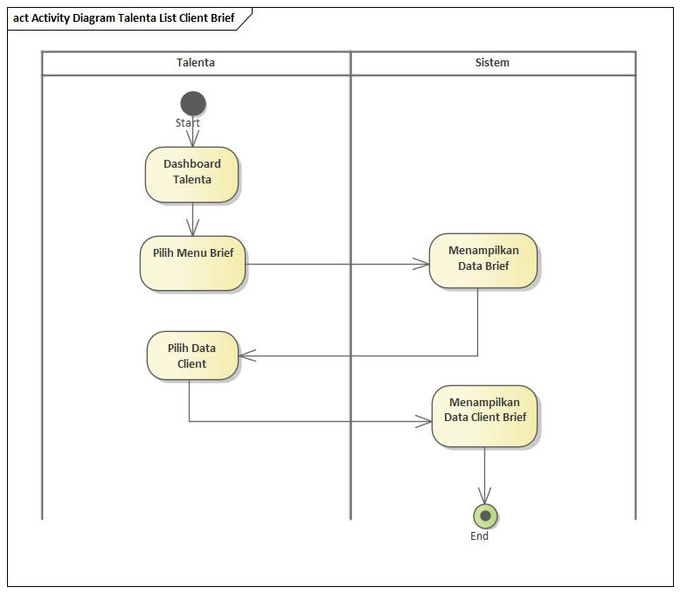**List Brief Client**
* 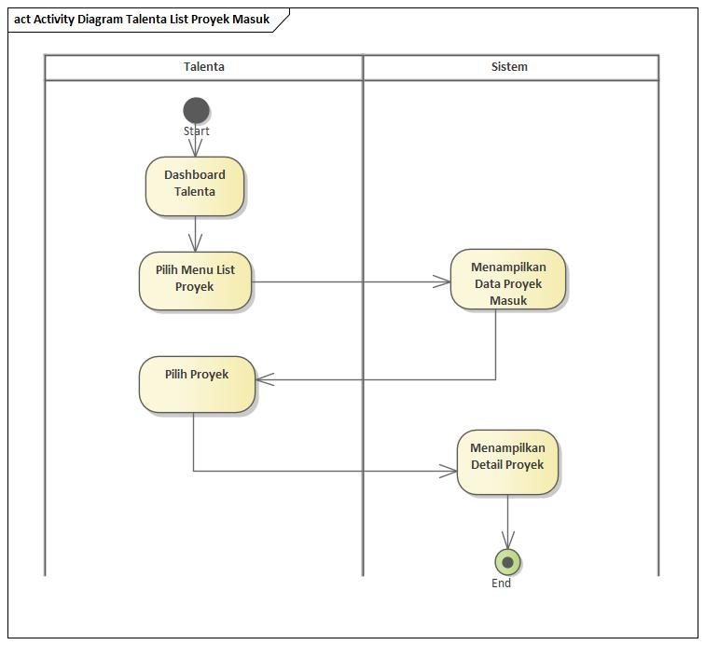**List Proyek Masuk**
* 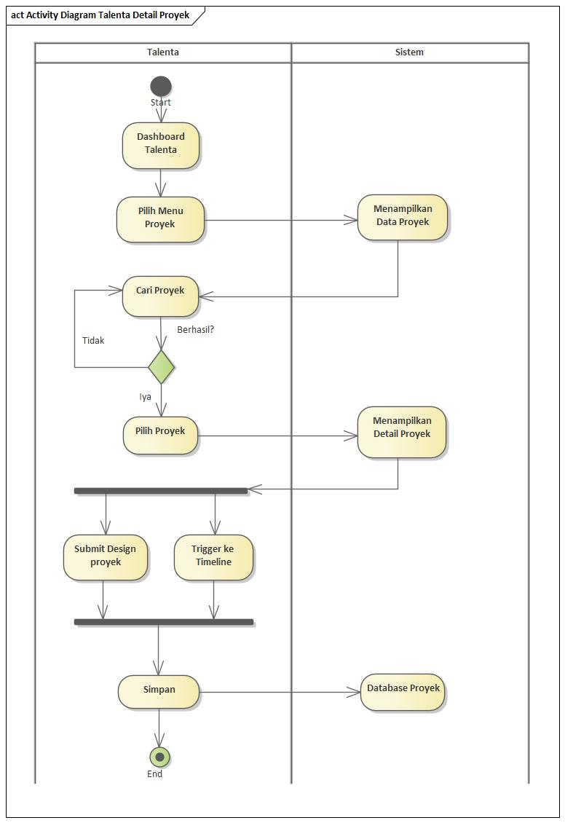**Detail Proyek**
* 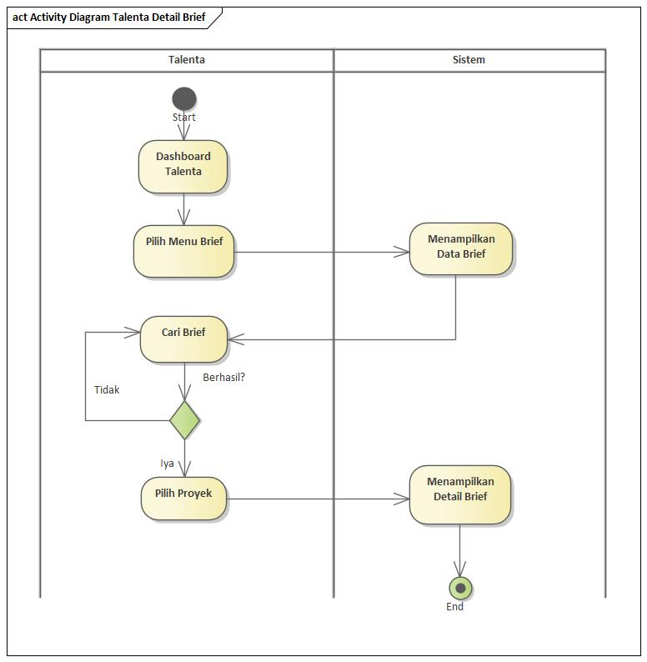**Detail Brief**
* 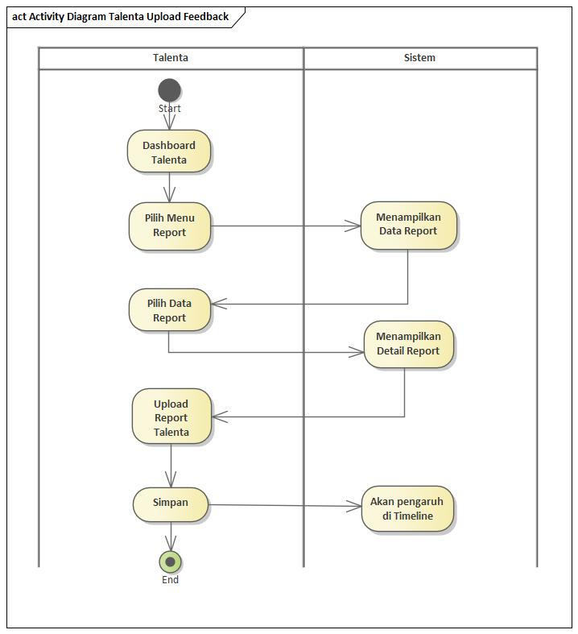**Upload Feedback**
* 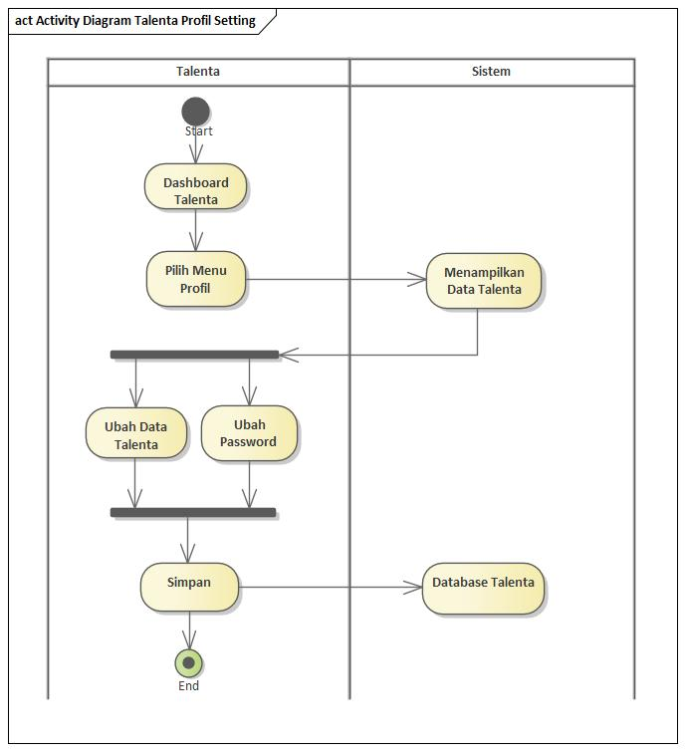**Profil Setting**
* 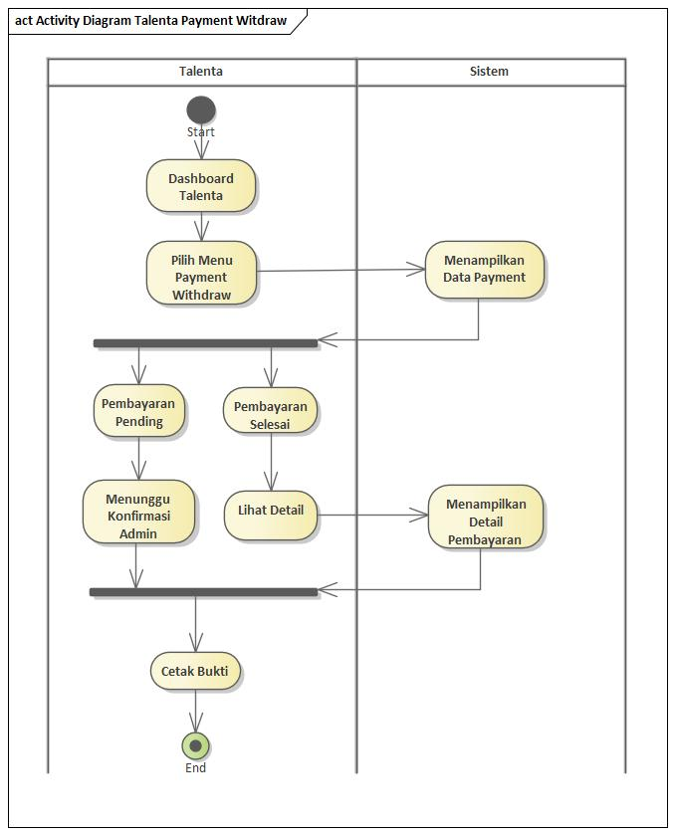**Payment Withdraw**
* 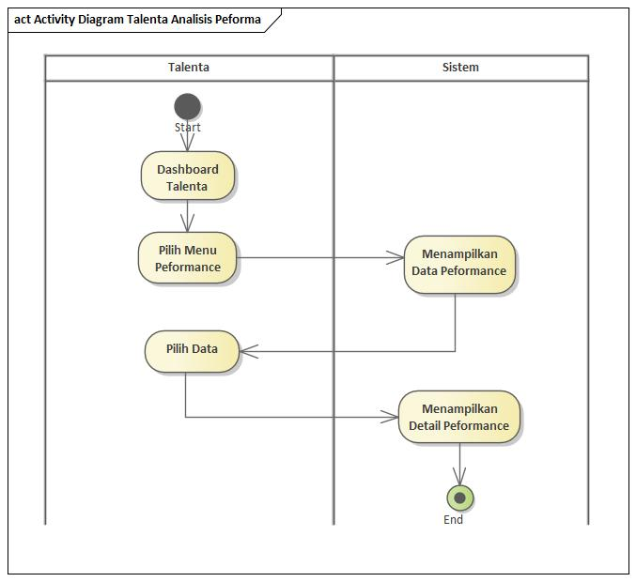**Analysis Peforma**
* 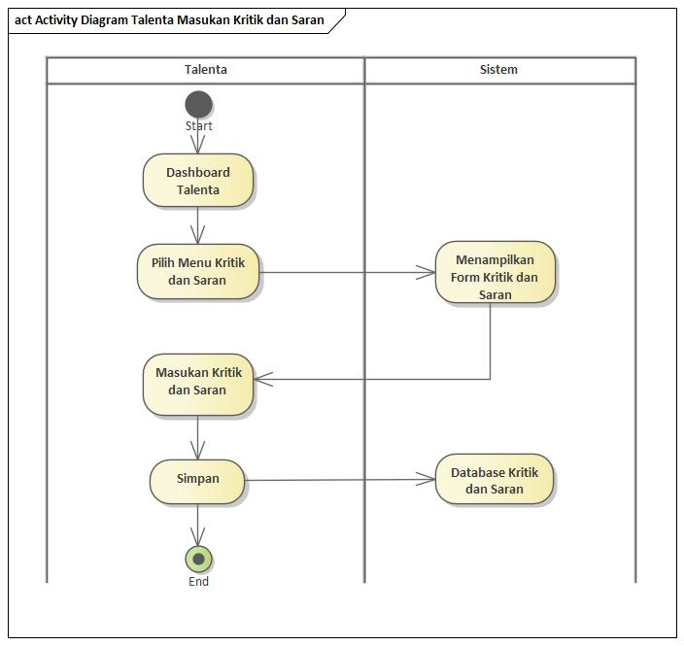**Masukan Kritik dan Saran**
* **Login & Register Talenta**

